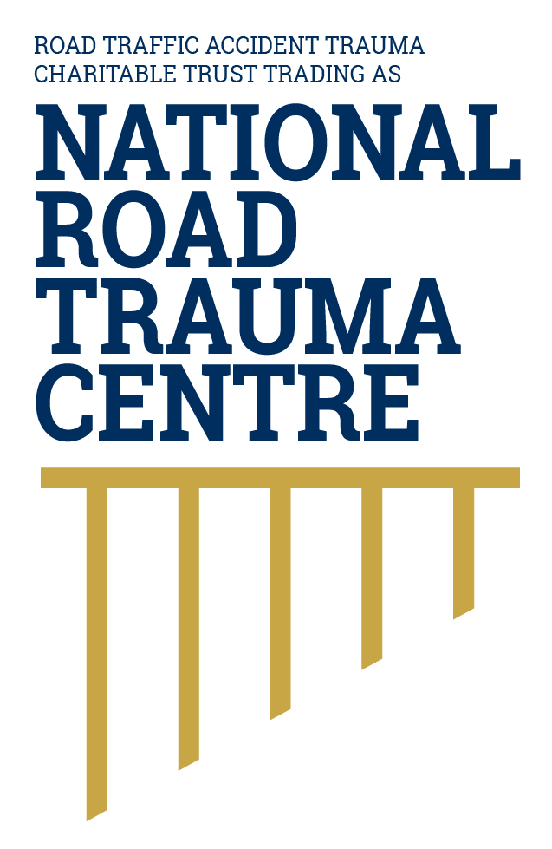
NATIONAL ROAD TRAUMA CENTRE RESOURCE HUB | RESOURCE 15

When to Call 111
Call 111 when someone is injured or in danger, or when a crash creates a serious and immediate risk to life or property.
You do not need to be certain that the situation is an emergency. If you are seriously worried, call 111 and explain what is happening. The operator will help work out what response is needed.

Call 111 After a Crash When
- Anyone may be injured, unconscious, confused, trapped or having difficulty breathing.
- There is severe bleeding, fire, smoke, leaking fuel, fallen power lines or another immediate hazard.
- A vehicle or debris is creating a serious danger to moving traffic.
- A person has left the scene after a serious crash or there is an immediate threat to safety.

What to Tell the Operator
- Say whether you need Police, Fire or Ambulance. More than one service may be sent.
- Give the location first: road name, direction of travel, nearest intersection, landmark or distance marker.
- Describe what happened, how many vehicles and people are involved, visible hazards and any known injuries.
- Give your phone number, stay on the line and follow instructions. Send someone to guide responders only if it is safe.

If It Is Not an Emergency
Use 105 or 105.police.govt.nz for non-urgent Police reporting. From a mobile phone, *555 can be used for urgent road incidents that are not life-threatening, such as a road obstruction or unsafe driving happening now. Healthline is available on 0800 611 116 for non-emergency health advice.

How This Connects With Patient-Centred Care
Calling 111 begins a coordinated patient-centred response. Information from the caller helps the call-taker, Police, ambulance, Fire and Emergency and receiving hospital understand what may be needed. When each part communicates clearly and works together, the injured person can receive the best possible care from the first call through transport and hospital treatment.

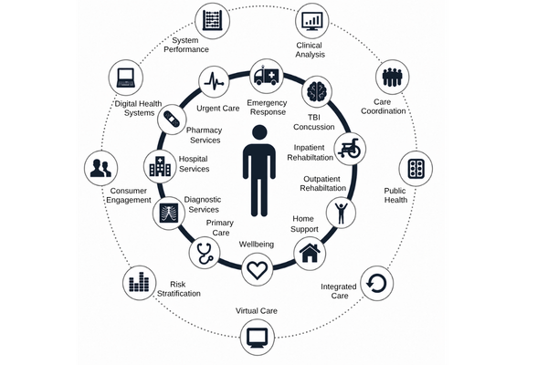
Figure 1. Patient Centred Care Approach
Patient-centred care works best when the patient is supported to understand and make decisions about their care, and all health professionals involved communicate and work together. This keeps the patient at the centre and helps ensure their care reflects their needs, circumstances and recovery goals.
Adapted by the National Road Trauma Centre (2019) from patient-centred care and integrated care principles.
Source: National Road Trauma Centre (2019).

About This Resource
This resource provides general public information informed by current evidence and official New Zealand guidance. The National Road Trauma Centre supports current New Zealand legislation, government guidance and evidence-based practice.

References
New Zealand Police. (n.d.). 111 Police emergency.
New Zealand Police. (2026). 105 Police non-emergency online reporting.
New Zealand Police. (n.d.). Report a road incident or unsafe driver.
Health New Zealand. (2026). Healthline.
NZ Transport Agency Waka Kotahi. (n.d.). Crashes.

About the National Road Trauma Centre
The Road Traffic Accident Trauma Charitable Trust trading as National Road Trauma Centre works across harm prevention, emergency response, healthcare, rehabilitation and recovery.
The National Road Trauma Centre Resource Hub is a New Zealand-first initiative specifically designed around the needs and experiences of people affected by road trauma in Aotearoa New Zealand. It brings together clear, trusted and neutral information grounded in current evidence, New Zealand government guidance and evidence-based practice.
The National Road Trauma Centre Resource Hub is intended for anyone seeking to understand road trauma, including people navigating their own recovery, families and whānau, general practitioners and other healthcare professionals, emergency services, community organisations, and people who simply want to learn more. It supports self-navigation and informed conversations about care, services and recovery.
The National Road Trauma Centre Resource Hub connects trusted information and services without replacing government agencies, emergency services, healthcare providers or support organisations.
If someone is in immediate danger or may be seriously injured, call 111.

