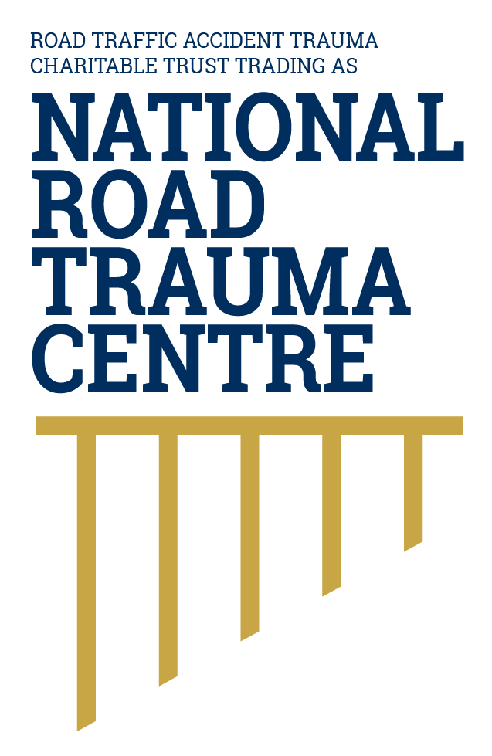
NATIONAL ROAD TRAUMA CENTRE RESOURCE HUB | RESOURCE 13

Understanding the Broader Impact of Road Trauma
The effects of road trauma can extend beyond the initial injuries and continue through daily life, relationships and recovery.
Every person’s experience is different. Some people recover quickly, while others live with ongoing physical, cognitive, emotional, practical or financial effects. These impacts may change over time and may not be visible to others.

Impact on the Injured Person
- Pain, fatigue, reduced mobility or other symptoms can affect sleep, self-care and independence.
- Concussion or brain injury may affect memory, concentration, communication, mood and tolerance of noise or activity.
- Distress, anxiety, low mood or trauma responses can occur after a frightening or life-changing event.
- Appointments, transport, rehabilitation, study, employment and financial changes can add practical pressure.

Impact on Families and Whānau
Family and whānau may provide transport, personal care, advocacy, childcare, household support or help with decisions. They may also experience uncertainty, stress, grief or changes in family roles. Support should recognise their needs without taking control away from the injured person.

Recovery Is Not Always Linear
Progress may occur in stages, and symptoms can improve, return or become more noticeable as daily demands increase. Patient-centred care focuses on the person’s goals, preferences, culture, communication needs and circumstances—not only the injury diagnosis.

How This Connects With Patient-Centred Care
Patient-centred care recognises that road trauma can affect physical health, emotional wellbeing, relationships, work, study and independence. The patient, hospital teams, primary care and rehabilitation services need to share relevant information and coordinate care around the person’s needs, goals and circumstances. When each part of the care pathway works together, the person is more likely to receive the right care at the right time.

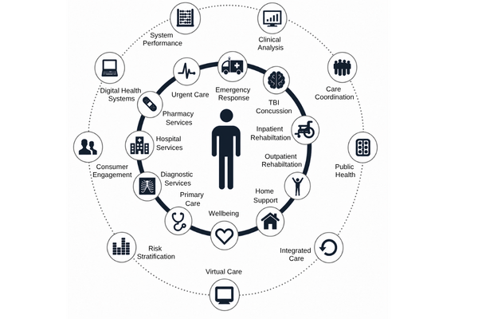
Figure 1. Patient Centred Care Approach
Patient-centred care works best when the patient is supported to understand and make decisions about their care, and all health professionals involved communicate and work together. This keeps the patient at the centre and helps ensure their care reflects their needs, circumstances and recovery goals.
Adapted by the National Road Trauma Centre (2019) from patient-centred care and integrated care principles.
Source: National Road Trauma Centre (2019).

About This Resource
This resource provides general public information informed by current evidence and official New Zealand guidance. The National Road Trauma Centre supports current New Zealand legislation, government guidance and evidence-based practice.

References
Health New Zealand. (2026). Major trauma annual report 2024/25.
ACC. (n.d.). How we support you and your whānau.
Health Quality & Safety Commission. (2026). Major Trauma Annual Report 2024/25.
Civil et al.. (2023). The New Zealand National Trauma Registry.
World Health Organization. (2023). Road traffic injuries.

About the National Road Trauma Centre
The Road Traffic Accident Trauma Charitable Trust trading as National Road Trauma Centre works across harm prevention, emergency response, healthcare, rehabilitation and recovery.
The National Road Trauma Centre Resource Hub is a New Zealand-first initiative specifically designed around the needs and experiences of people affected by road trauma in Aotearoa New Zealand. It brings together clear, trusted and neutral information grounded in current evidence, New Zealand government guidance and evidence-based practice.
The National Road Trauma Centre Resource Hub is intended for anyone seeking to understand road trauma, including people navigating their own recovery, families and whānau, general practitioners and other healthcare professionals, emergency services, community organisations, and people who simply want to learn more. It supports self-navigation and informed conversations about care, services and recovery.
The National Road Trauma Centre Resource Hub connects trusted information and services without replacing government agencies, emergency services, healthcare providers or support organisations.
If someone is in immediate danger or may be seriously injured, call 111.

