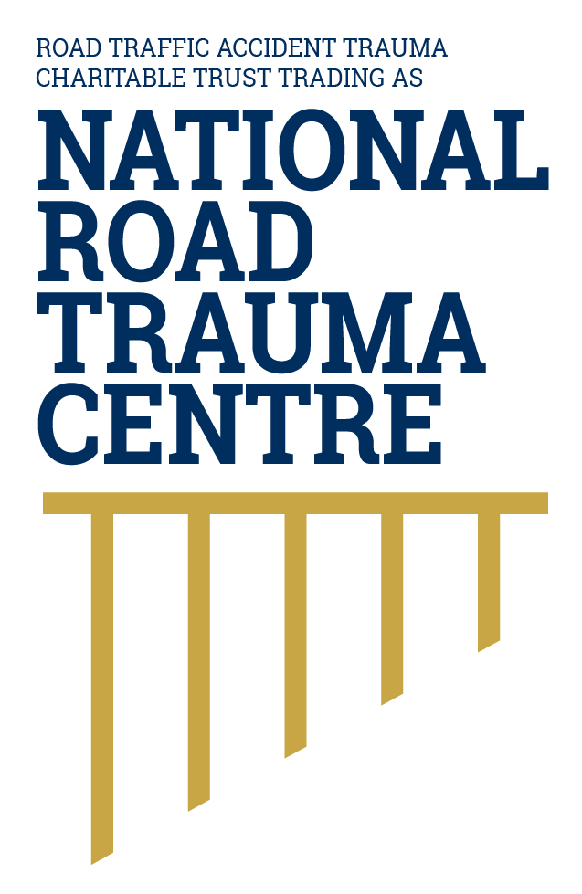
NATIONAL ROAD TRAUMA CENTRE RESOURCE HUB | RESOURCE 12

Why Prevention and Response Are Connected
Preventing serious harm includes reducing crash risk and making sure effective help can reach an injured person quickly.
The safe system does not assume that every crash can be prevented. It combines protections before, during and after a crash so that one mistake is less likely to result in death or life-changing injury.

Before a Crash
- Safer roads and roadsides reduce conflict and shield people from hazards.
- Safer speeds provide more time to respond and reduce impact forces.
- Safer vehicles help avoid crashes and protect occupants and other road users.
- Safe road use includes being alert, restrained, attentive and unimpaired.

After a Crash
Post-crash care begins with recognising danger, calling 111 and providing safe assistance within a person’s ability. Emergency responders assess and stabilise patients, manage scene hazards and arrange transport to appropriate care.

Why Time and Coordination Matter
Serious injuries can affect breathing, circulation and the brain. Early information from a 111 caller helps emergency services decide what response may be required. Coordination between Police, ambulance, Fire and Emergency, rescue services and hospitals helps the person move through the system safely.

Patient Centred Care Throughout
The person’s needs do not end when the immediate danger passes. Patient-centred care means the patient, ambulance and emergency care, hospital teams, primary care and rehabilitation work together across the full pathway. Shared information, clear referrals, coordinated decisions and follow-up help the person receive the best possible care.

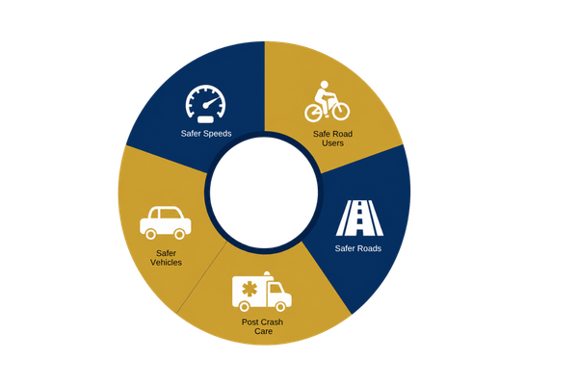
Figure 1. Safe System Model
Post-crash care is an essential safe system layer connecting the crash scene with emergency response, hospital care, rehabilitation and recovery.
Adapted from the Ministry of Transport's Safe System approach as outlined in Road to Zero: New Zealand's Road Safety Strategy 2020–2030.
Source: National Road Trauma Centre, adapted from Ministry of Transport (2020).
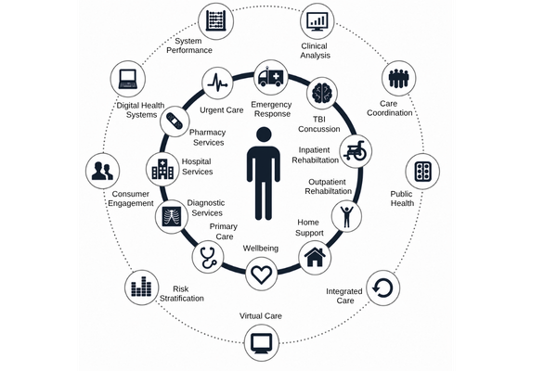
Figure 2. Patient Centred Care Approach
Patient-centred care works best when the patient is supported to understand and make decisions about their care, and all health professionals involved communicate and work together. This keeps the patient at the centre and helps ensure their care reflects their needs, circumstances and recovery goals.
Adapted by the National Road Trauma Centre (2019) from patient-centred care and integrated care principles.
Source: National Road Trauma Centre (2019).

About This Resource
This resource provides general public information informed by current evidence and official New Zealand guidance. The National Road Trauma Centre supports current New Zealand legislation, government guidance and evidence-based practice.

References
NZ Transport Agency Waka Kotahi. (n.d.). Creating a safe road system.
World Health Organization. (2021). Global Plan for the Decade of Action for Road Safety 2021 to 2030.
Health New Zealand. (2026). Major trauma annual report 2024/25.
Civil et al.. (2023). The New Zealand National Trauma Registry.
New Zealand Police. (n.d.). 111 Police emergency.

About the National Road Trauma Centre
The Road Traffic Accident Trauma Charitable Trust trading as National Road Trauma Centre works across harm prevention, emergency response, healthcare, rehabilitation and recovery.
The National Road Trauma Centre Resource Hub is a New Zealand-first initiative specifically designed around the needs and experiences of people affected by road trauma in Aotearoa New Zealand. It brings together clear, trusted and neutral information grounded in current evidence, New Zealand government guidance and evidence-based practice.
The National Road Trauma Centre Resource Hub is intended for anyone seeking to understand road trauma, including people navigating their own recovery, families and whānau, general practitioners and other healthcare professionals, emergency services, community organisations, and people who simply want to learn more. It supports self-navigation and informed conversations about care, services and recovery.
The National Road Trauma Centre Resource Hub connects trusted information and services without replacing government agencies, emergency services, healthcare providers or support organisations.
If someone is in immediate danger or may be seriously injured, call 111.

