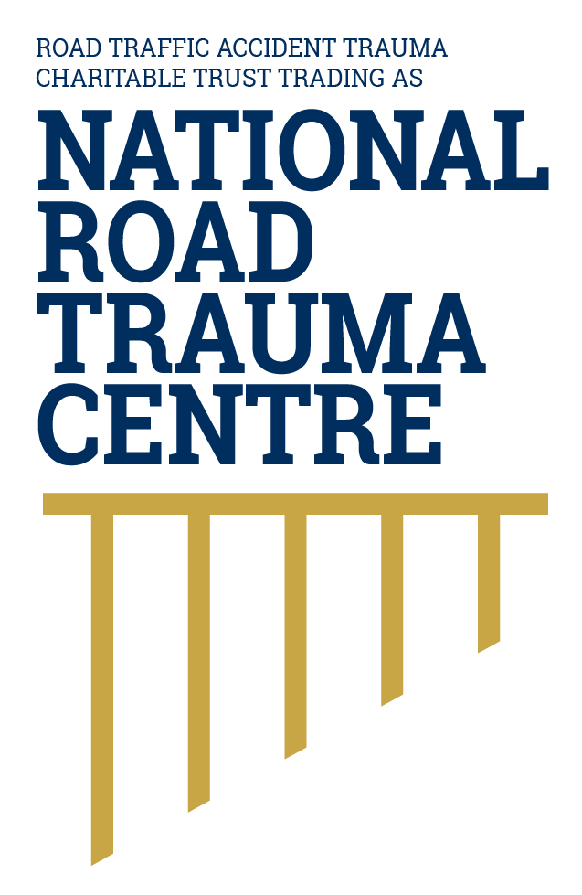
NATIONAL ROAD TRAUMA CENTRE RESOURCE HUB | RESOURCE 10

How Road Trauma Affects the Body
In a crash, the body may be forced to stop, twist or change direction suddenly, causing injuries that are not always visible.
The body continues moving until something restrains or stops it. Seatbelts, airbags, helmets, vehicle structure and roadside protection are designed to manage this energy, but the forces in a crash can still injure several parts of the body at once.

How Injury Happens
- A direct impact can damage skin, muscles, bones, organs and blood vessels.
- Rapid movement or rotation can stretch, compress or tear tissues, including in the brain, neck and spine.
- An unrestrained person can strike the vehicle interior or be thrown from the vehicle, greatly increasing exposure to harmful forces.
- The type of crash, speed, direction of impact, vehicle protection, restraint use, age and health all influence injury.

Injuries May Affect More Than One Area
Road trauma can involve the head and brain, face, chest, abdomen, pelvis, spine and limbs. Bleeding, swelling or reduced oxygen can also affect the body after the initial impact. Some injuries are immediately obvious; others are found through monitoring, examination or imaging.

Signs That Need Urgent Help
Call 111 if a person may be seriously injured, is unconscious or confused, has difficulty breathing, severe bleeding, weakness or numbness, worsening pain, repeated vomiting, a seizure, or any rapid deterioration. Follow the call-taker’s instructions.

How the Safe System and Patient-Centred Care Work Together
The safe system reduces the forces that can injure the body through safer roads, safer speeds, safer vehicles and safe road use. After a crash, patient-centred care connects ambulance, hospital teams, diagnostic services, primary care, rehabilitation and other support. When these services share information and coordinate decisions, injuries are less likely to be missed and the person can receive the best possible care from emergency treatment through recovery.

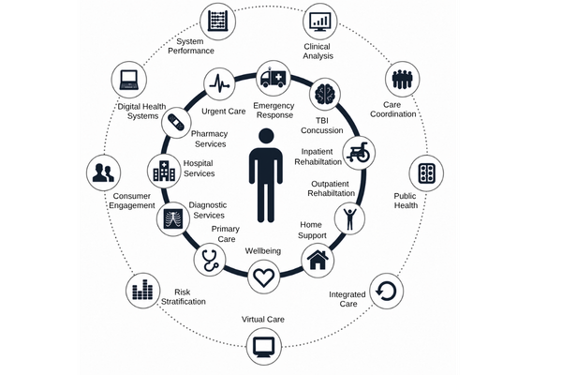
Figure 1. Patient Centred Care Approach
Patient-centred care works best when the patient is supported to understand and make decisions about their care, and all health professionals involved communicate and work together. This keeps the patient at the centre and helps ensure their care reflects their needs, circumstances and recovery goals.
Adapted by the National Road Trauma Centre (2019) from patient-centred care and integrated care principles.
Source: National Road Trauma Centre (2019).

About This Resource
This resource provides general public information informed by current evidence and official New Zealand guidance. The National Road Trauma Centre supports current New Zealand legislation, government guidance and evidence-based practice.

References
NZ Transport Agency Waka Kotahi. (n.d.). Creating a safe road system.
Health New Zealand. (2026). Major trauma annual report 2024/25.
Health New Zealand. (2026). Emergency departments.
New Zealand Police. (n.d.). 111 Police emergency.
World Health Organization. (2023). Road traffic injuries.

About the National Road Trauma Centre
The Road Traffic Accident Trauma Charitable Trust trading as National Road Trauma Centre works across harm prevention, emergency response, healthcare, rehabilitation and recovery.
The National Road Trauma Centre Resource Hub is a New Zealand-first initiative specifically designed around the needs and experiences of people affected by road trauma in Aotearoa New Zealand. It brings together clear, trusted and neutral information grounded in current evidence, New Zealand government guidance and evidence-based practice.
The National Road Trauma Centre Resource Hub is intended for anyone seeking to understand road trauma, including people navigating their own recovery, families and whānau, general practitioners and other healthcare professionals, emergency services, community organisations, and people who simply want to learn more. It supports self-navigation and informed conversations about care, services and recovery.
The National Road Trauma Centre Resource Hub connects trusted information and services without replacing government agencies, emergency services, healthcare providers or support organisations.
If someone is in immediate danger or may be seriously injured, call 111.

