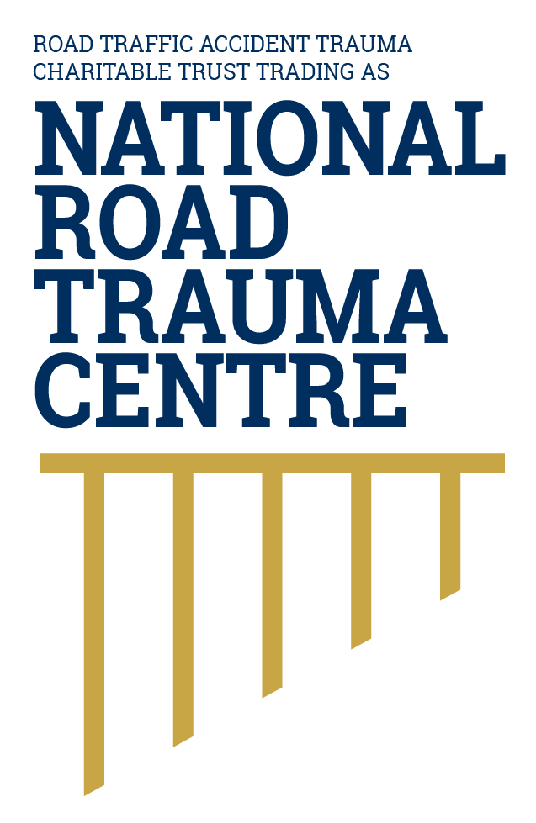
NATIONAL ROAD TRAUMA CENTRE RESOURCE HUB | RESOURCE 07

Driving Safely in Adverse Weather Conditions
Check conditions before leaving, slow down, increase following distance and postpone travel when the risk cannot be managed safely.
Rain, surface water, snow, ice, fog, strong wind and bright low sun can reduce visibility, grip and vehicle stability. In the safe system, people respond by reducing speed, increasing space and using a suitable vehicle. Conditions can change quickly, especially on rural, alpine and exposed roads. The safest decision may be to delay or change the journey.

Before Leaving
- Check MetService forecasts, severe weather watches and warnings, including road snowfall warnings where relevant.
- Check NZ Transport Agency Waka Kotahi journey information for closures, restrictions, warnings and travel times.
- Make sure tyres, lights, brakes, wipers, demisters and screen wash are working. These safer-vehicle features support grip, visibility and control. Clear all windows and lights before moving.
- Carry suitable clothing, water, essential medication and a charged phone on longer or remote journeys. Tell someone your route when appropriate.

On the Road
- Reduce speed smoothly and leave at least a four-second gap. This provides more time to see, react and stop. Choose a fixed point ahead; after the vehicle in front passes it, your vehicle should reach it no sooner than four seconds later. Leave a larger gap when conditions are very poor.
- Use headlights when visibility is poor. Use fog lights only when conditions justify them and switch them off when visibility improves.
- Brake, steer and accelerate gently. Avoid cruise control when conditions require frequent speed changes or grip may be reduced.
- Watch for shaded areas, bridges and hill roads where ice may form. Do not assume a wet-looking surface is only water.
- In strong winds, reduce speed, keep both hands on the wheel and allow extra space around high-sided vehicles, cyclists and motorcyclists.

Rain and Flooding
Surface water can cause loss of steering control and hide road damage. Slow down before reaching water, avoid sudden inputs and never enter floodwater when you cannot confirm it is shallow, still and safe. Turn around when a road is closed or the depth, current or road surface is uncertain.

Fog, Snow and Ice
In fog, use dipped headlights, slow down and avoid following tail lights too closely. In snow or ice, travel only when necessary and when your vehicle and skills are suitable. Follow signs, restrictions and official advice about chains. Never make a sudden manoeuvre on a slippery surface.

If Continuing Is Unsafe
Find a safe place completely away from live traffic and reassess. Do not stop on a bend, crest, narrow shoulder or in a live lane unless an emergency makes this unavoidable. For immediate danger call 111. For state highway conditions, use Journey Planner or call 0800 4 HIGHWAYS (0800 44 44 49).

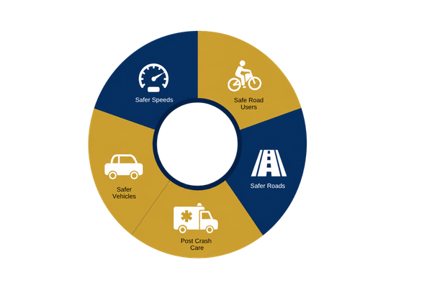

Figure 1. Safe system model
In adverse weather, safer speeds, safer roads, safer vehicles, safe road use and post-crash care all contribute to safety.
Source: National Road Trauma Centre, adapted from the New Zealand Government’s safe system approach.

About This Resource
This resource provides general public information informed by current evidence and official New Zealand guidance. The National Road Trauma Centre supports current New Zealand legislation, government guidance and evidence-based practice.

References
NZ Transport Agency Waka Kotahi. (n.d.). Driving in bad weather.
NZ Transport Agency Waka Kotahi. (n.d.). Winter driving.
NZ Transport Agency Waka Kotahi. (n.d.). Following distance.
NZ Transport Agency Waka Kotahi. (n.d.). Creating a safe road system.
NZ Transport Agency Waka Kotahi. (n.d.). Journey Planner.
MetService. (n.d.). Weather warnings and watches.
New Zealand Police. (n.d.). Personal safety in your vehicle.

About the National Road Trauma Centre
The Road Traffic Accident Trauma Charitable Trust trading as National Road Trauma Centre works across harm prevention, emergency response, healthcare, rehabilitation and recovery. The National Road Trauma Centre Resource Hub connects trusted information and services without replacing government agencies, emergency services, healthcare providers or support organisations.
If someone is in immediate danger or may be seriously injured, call 111.

