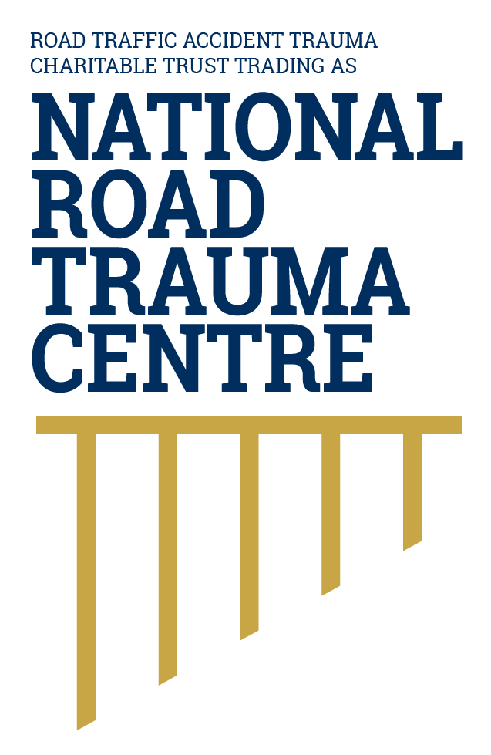
NATIONAL ROAD TRAUMA CENTRE RESOURCE HUB | RESOURCE 06

Safe Road Use in Everyday Life
Everyday road use is safer when people are alert, restrained, unimpaired, attentive and prepared for changing conditions.
Safe road use is one layer of a safe system. Everyday choices can reduce risk, while safer roads, safer speeds, safer vehicles and post-crash care provide other layers of protection when a mistake or crash occurs.

Before You Travel
- Check that you are licensed for the vehicle and fit to drive. Do not drive when fatigue, alcohol, drugs, illness or medication may impair you.
- Plan the route, allow enough time and check weather and road conditions for longer or unfamiliar journeys.
- Make sure the vehicle is roadworthy, the load is secure and everyone has an appropriate seating position and restraint.
- Set navigation, music and climate controls before moving. Put the phone away so it cannot distract you.

While Driving
- Wear your seatbelt correctly and make sure children use approved restraints appropriate for their age and size. Restraints help manage crash forces by holding people in the position the vehicle’s safety systems are designed to protect.
- Stay within the speed limit and choose a lower speed when conditions require it. Safer speeds give you more time to respond and reduce the force transferred to people if a crash occurs.
- Leave at least a two-second gap in normal conditions. Choose a fixed point ahead; after the vehicle in front passes it, your vehicle should reach it no sooner than two seconds later. Use at least four seconds on wet or slippery roads, in poor conditions or when towing.
- Scan ahead, check mirrors and blind spots, signal in good time and create space around people walking, cycling and riding motorcycles.
- Take a proper break when tired. Fresh air, loud music and opening a window do not cure fatigue.

Share the Road
The safe system recognises that people can misjudge speed or distance and may make mistakes. Some people also have less physical protection or limited visibility or mobility. Leave space, avoid retaliatory behaviour and be patient around learners, children, older people, cyclists, motorcyclists, road workers, agricultural vehicles and emergency scenes.

If Something Changes
- Slow down and increase following distance when traffic, weather, light or the road surface changes.
- If you become unwell, distressed or too tired to continue, stop in a safe place away from moving traffic.
- If a warning light, tyre problem or mechanical fault affects safety, stop safely and arrange assistance.
- Call 111 for an immediate threat to life or safety.

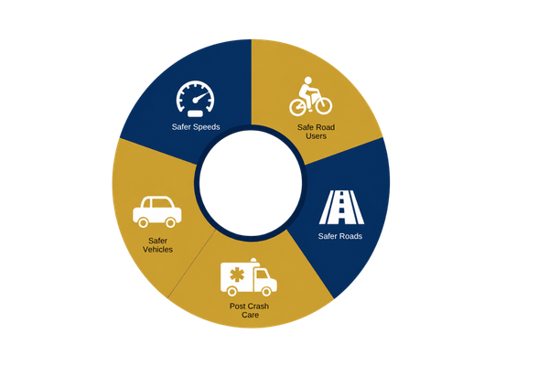
Figure 1. Safe system model
This resource focuses on safe road use as one of several connected layers of protection.
Source: National Road Trauma Centre, adapted from the New Zealand Government’s safe system approach.

About This Resource
This resource provides general public information informed by current evidence and official New Zealand guidance. The National Road Trauma Centre supports current New Zealand legislation, government guidance and evidence-based practice.

References
NZ Transport Agency Waka Kotahi. (n.d.). General road code.
NZ Transport Agency Waka Kotahi. (n.d.). Safe driving habits.
NZ Transport Agency Waka Kotahi. (n.d.). Driver fatigue.
NZ Transport Agency Waka Kotahi. (n.d.). Following distance.
NZ Transport Agency Waka Kotahi. (n.d.). Creating a safe road system.
New Zealand Police. (n.d.). Being safe on the road - rules and reasons.

About the National Road Trauma Centre
The Road Traffic Accident Trauma Charitable Trust trading as National Road Trauma Centre works across harm prevention, emergency response, healthcare, rehabilitation and recovery. The National Road Trauma Centre Resource Hub connects trusted information and services without replacing government agencies, emergency services, healthcare providers or support organisations.
If someone is in immediate danger or may be seriously injured, call 111.

