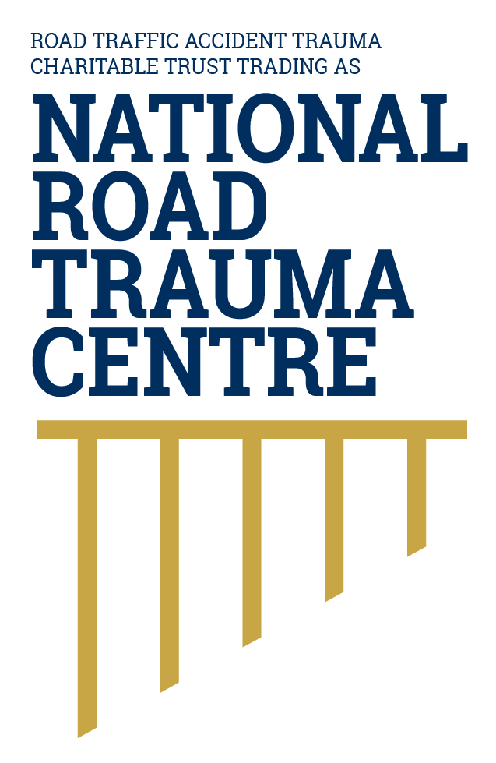
NATIONAL ROAD TRAUMA CENTRE RESOURCE HUB | RESOURCE 05

Safer Vehicles for Everyday Road Use
A safer vehicle can help prevent a crash and provide better protection for occupants and other road users when a crash occurs.
Safer vehicles are one layer of the safe system. Vehicles differ in how well they prevent crashes and protect occupants and people outside the vehicle. A current safety rating can help you compare vehicles before buying one. Regular checks and maintenance matter because safety features can only work properly when the vehicle is roadworthy.

Choose Safety Deliberately
- Check the vehicle’s current safety rating on Rightcar before buying it. Ratings can change as more crash information becomes available and testing methods are updated.
- Choose the highest-rated vehicle that reasonably meets your needs and budget. Consider protection for occupants and for people outside the vehicle.
- Look for effective crash-avoidance features, including autonomous emergency braking and lane-support systems. These features support the safer-vehicles layer by helping avoid or reduce the severity of some crashes, but they do not replace attentive driving.
- Make sure the vehicle is suitable for its passengers, any load or trailer, the roads you use and the person driving it.

Keep Vehicles Roadworthy
- Maintain the vehicle to the manufacturer’s schedule and promptly address warning lights, unusual noises or handling changes. Maintenance helps ensure that brakes, tyres, lights and safety systems respond as intended.
- Regularly check tyres, tread, pressure, lights, brakes, mirrors, windscreens, wipers and fluid levels.
- A current warrant or certificate of fitness is a minimum check at one point in time. It does not replace ongoing maintenance.
- Secure tools, equipment and other loads so they cannot move during normal travel, sudden braking or a crash.

Know the Vehicle Before You Drive
- Adjust the seat, steering wheel, mirrors and head restraint before moving.
- Know how to operate the lights, demisters, windscreen wipers, hazard lights and driver-assistance features.
- Check the dashboard after starting. Do not ignore a warning light or a change in braking, steering, tyres or handling.
- Secure luggage and other loose items so they cannot move during sudden braking or a crash.
- Do not drive a vehicle you reasonably believe is unsafe. Arrange inspection or assistance before continuing.

Before Every Journey
Adjust the seat and head restraint so the vehicle and restraints can provide the intended protection. Fasten every occupant’s seatbelt, check mirrors and visibility, secure loose items and confirm the vehicle is fit for the trip. These actions connect safer vehicles with safe road use. Never drive a vehicle you reasonably believe is unsafe.

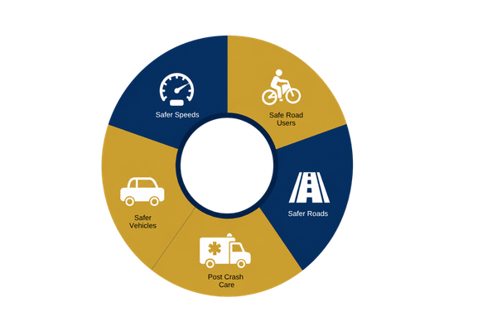
Figure 1. Safe system model
This resource focuses on safer vehicles and their role in avoiding crashes and protecting people when crashes occur.
Source: National Road Trauma Centre, adapted from the New Zealand Government’s safe system approach.

About This Resource
This resource provides general public information informed by current evidence and official New Zealand guidance. The National Road Trauma Centre supports current New Zealand legislation, government guidance and evidence-based practice.

References
NZ Transport Agency Waka Kotahi. (n.d.). Vehicle safety ratings.
NZ Transport Agency Waka Kotahi. (2023). Rightcar for vehicle safety and environmental ratings.
NZ Transport Agency Waka Kotahi. (n.d.). Creating a safe road system.
NZ Transport Agency Waka Kotahi. (n.d.). General road code.
New Zealand Police. (n.d.). Personal safety in your vehicle.

About the National Road Trauma Centre
The Road Traffic Accident Trauma Charitable Trust trading as National Road Trauma Centre works across harm prevention, emergency response, healthcare, rehabilitation and recovery. The National Road Trauma Centre Resource Hub connects trusted information and services without replacing government agencies, emergency services, healthcare providers or support organisations.
If someone is in immediate danger or may be seriously injured, call 111.

