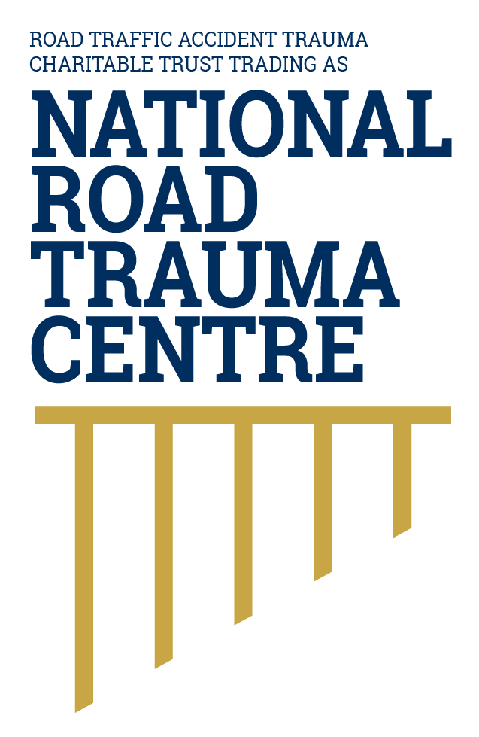
NATIONAL ROAD TRAUMA CENTRE RESOURCE HUB | RESOURCE 04

Safer Roads and Roadsides
Roads can be designed and maintained so that common mistakes are less likely to cause death or serious injury.
A safer road is understandable, predictable and appropriate for the people who use it. A safer roadside reduces the chance that a vehicle leaving its lane will strike an unforgiving object or overturn. Good design also protects people walking, cycling and using mobility devices.

Features That Can Reduce Serious Harm
- Median barriers help prevent high-energy head-on crashes by separating opposing traffic.
- Roadside barriers can shield people from hazards such as deep ditches, poles and large trees where those hazards cannot be removed or relocated.
- Centre and edge markings, wide centrelines and rumble strips help drivers recognise lane position and receive warning when drifting.
- Roundabouts, raised treatments, protected turn facilities and well-designed intersections can reduce conflict or impact speed.
- Footpaths, safe crossings and separated cycling facilities reduce exposure for people without vehicle protection.
- Maintenance, drainage, skid resistance, lighting, signs and vegetation management help roads remain legible and usable in changing conditions.

How This Connects with the Safe System
No road treatment works alone. The right treatment depends on the road, speed, traffic, crash history, surroundings and the people who use the area. Safer roads must work together with safer speeds, safer vehicles, safe road use and post-crash care to provide several layers of protection.

What Road Users Can Do
- Read the road ahead and adjust speed for bends, intersections, surface changes, roadside activity and limited visibility. This allows safer roads and safer speeds to work together.
- Keep within your lane and leave a safety cushion around cyclists, parked vehicles, driveways and roadside workers.
- Follow temporary traffic controls and slow down around maintenance and emergency crews. Temporary signs and lower speeds help manage risks when the usual road layout or conditions have changed.
- Avoid stopping on narrow shoulders, bends or crests unless an emergency leaves no safer option.

Reporting A Hazard
For an immediate threat to life, call 111. From a mobile phone, call *555 for an urgent road incident that is not life-threatening, such as a non-injury crash, breakdown or highway obstruction. Report hazards on state highways to NZ Transport Agency Waka Kotahi on 0800 4 HIGHWAYS (0800 44 44 49), and local-road hazards to the relevant city or district council. Give the road name, direction of travel, nearest landmark and a clear description without placing yourself at risk.

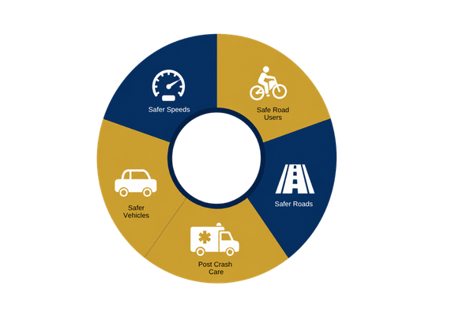
Figure 1. Safe system model
This resource focuses on safer roads and how road design supports the other parts of the safe system.
Source: National Road Trauma Centre, adapted from the New Zealand Government’s safe system approach.

About This Resource
This resource provides general public information informed by current evidence and official New Zealand guidance. The National Road Trauma Centre supports current New Zealand legislation, government guidance and evidence-based practice.

References
NZ Transport Agency Waka Kotahi. (n.d.). High-risk rural roads guide.
NZ Transport Agency Waka Kotahi. (n.d.). Standard safety intervention toolkit.
NZ Transport Agency Waka Kotahi. (n.d.). Safe driving tips.
NZ Transport Agency Waka Kotahi. (n.d.). Creating a safe road system.
Ministry of Transport. (2026). New Zealand’s Road Safety Objectives.
New Zealand Police. (n.d.). Report a road incident or unsafe driver - *555 and Roadwatch.

About the National Road Trauma Centre
The Road Traffic Accident Trauma Charitable Trust trading as National Road Trauma Centre works across harm prevention, emergency response, healthcare, rehabilitation and recovery. The National Road Trauma Centre Resource Hub connects trusted information and services without replacing government agencies, emergency services, healthcare providers or support organisations.
If someone is in immediate danger or may be seriously injured, call 111.

