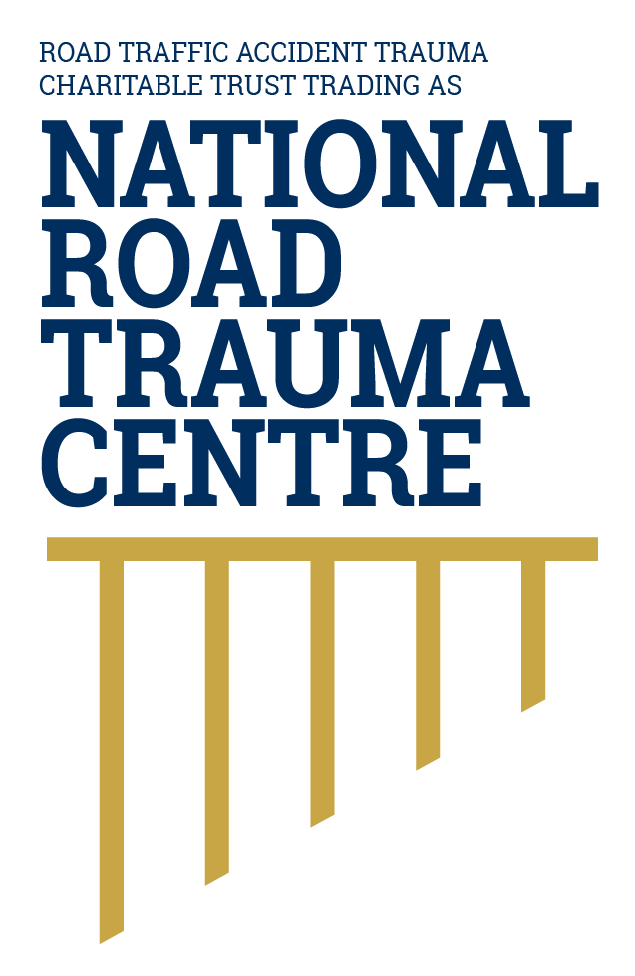
NATIONAL ROAD TRAUMA CENTRE RESOURCE HUB | RESOURCE 03

Safer Speeds and Human Vulnerability
A posted speed limit is a legal maximum. A safe travel speed may be lower when the road, traffic, visibility or weather changes.
Speed affects whether a driver can avoid a crash and how severe the injuries are if a crash occurs. Small increases in speed can substantially increase crash energy. People outside vehicles, motorcyclists and occupants in side-impact or head-on crashes are especially vulnerable.

Why Speed Changes Outcomes
- Lower speeds give drivers more time to see a hazard, react and stop.
- The faster a vehicle is travelling, the further it will travel before it can stop. Wet, icy, loose or uneven surfaces increase stopping distance further.
- Higher speeds also increase the force of a crash. When speed doubles, the kinetic energy involved is four times greater.
- The outcome of a crash depends on many factors, including the type and direction of impact, the protection provided by the vehicle, restraint use, age and health. No speed can guarantee survival, but reducing speed can reduce the risk and severity of injury.

Choose A Speed for the Conditions
- Stay within the posted limit and reduce speed further when the road is winding, narrow, wet, icy, gravelled or difficult to see along. In the safe system, speed should reflect the road, conditions and people who may be exposed to harm.
- Slow down around people walking or cycling, schools, roadworks, stock, parked vehicles and busy roadside activity.
- Leave at least a two-second gap in normal conditions. When the vehicle ahead passes a fixed point, such as a sign or road marking, your vehicle should reach that point no sooner than two seconds later. Increase the gap to at least four seconds on wet or slippery roads, in poor conditions or when towing.
- Approach bends and crests at a speed that lets you stop within the clear distance you can see. This creates time and space to respond if the road ahead is blocked.
- Do not let a following vehicle pressure you into travelling faster. Let it pass when you can do so safely.

How This Connects with the Safe System
Drivers choose their travel speed, while road design, posted limits, signs, enforcement and vehicle technology also influence safety. The safe system approach matches speeds to the protection provided by the road and vehicle, and to the people who may be involved if a crash occurs.

If Conditions Deteriorate
Reduce speed smoothly, increase following distance, switch on lights when visibility is poor and avoid sudden steering or braking. If you cannot continue safely, stop somewhere well away from moving traffic. Do not stop in a live lane unless an emergency makes it unavoidable.

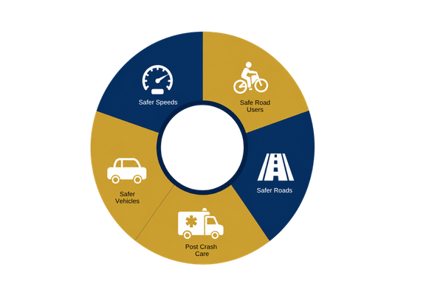
Figure 1. Safe System Model
This resource focuses on safer speeds and their connection with roads, vehicles, road use and post-crash care.
Source: National Road Trauma Centre, adapted from the New Zealand Government’s safe system approach.

About this Resource
This resource provides general public information informed by current evidence and official New Zealand guidance. The National Road Trauma Centre supports current New Zealand legislation, government guidance and evidence-based practice.

References
NZ Transport Agency Waka Kotahi. (n.d.). Speed limits.
NZ Transport Agency Waka Kotahi. (n.d.). Following distance.
NZ Transport Agency Waka Kotahi. (n.d.). Following speed limits.
NZ Transport Agency Waka Kotahi. (n.d.). Creating a safe road system.
Ministry of Transport. (2022). Impact Summary Tackling Unsafe Speeds.
New Zealand Police. (n.d.). Speed limits and enforcement.

About the National Road Trauma Centre
The Road Traffic Accident Trauma Charitable Trust trading as National Road Trauma Centre works across harm prevention, emergency response, healthcare, rehabilitation and recovery. The National Road Trauma Centre Resource Hub connects trusted information and services without replacing government agencies, emergency services, healthcare providers or support organisations.
If someone is in immediate danger or may be seriously injured, call 111.

