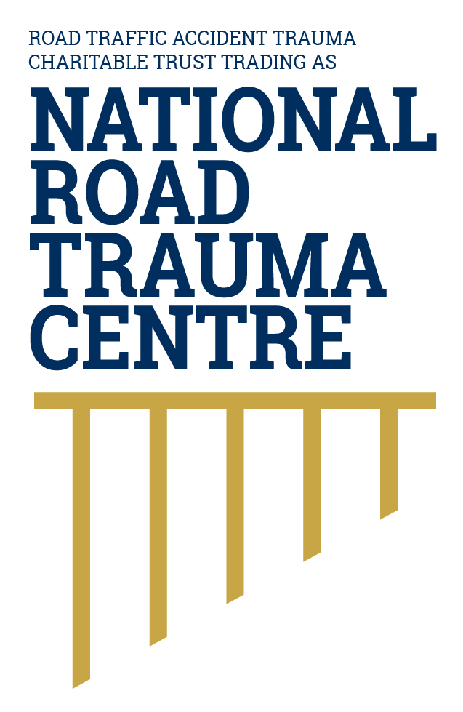
NATIONAL ROAD TRAUMA CENTRE RESOURCE HUB | RESOURCE 02

Why Road Trauma Is Preventable
Crashes may have many causes, but deaths and serious injuries can be reduced through proven protections across the transport system.
Calling road trauma preventable does not mean that every crash can be predicted or that one person is always to blame. It means the likelihood and severity of harm can be reduced when risks are identified early and multiple protections work together.

Prevention is More Than Avoiding Crashes
Some measures prevent a collision. Others reduce the energy of a collision or protect the body when a crash occurs. Fast access to emergency care can improve survival and recovery. Effective prevention therefore extends from road design and vehicle standards to road use and post-crash care.

How Serious Harm is Prevented
- Separate movements that can produce severe crashes, including opposing traffic and people travelling at very different speeds.
- Use road and roadside features that reduce the chance of a mistake becoming a fatal or serious-injury crash.
- Set and choose speeds that are appropriate for the road environment and the people who may be present.
- Increase the use of vehicles with strong crash protection and effective crash-avoidance technology.
- Reduce impairment, distraction, fatigue and non-use of restraints through road rules, enforcement, education and safer everyday choices.
- Provide timely emergency response, trauma care, rehabilitation and coordinated recovery support.

A Shared Responsibility
Everyone using the road has responsibilities under road law and can make safer choices. Government agencies, road controlling authorities, vehicle manufacturers and emergency and health services also shape the roads, vehicles, rules and care that protect people. This is a central idea of the safe system approach: no single person or safety measure can prevent every serious outcome, so several layers of protection must work together.

Practical Actions
- Plan journeys to avoid tiredness and time pressure and to allow for poor weather. This supports alert, adaptable road use.
- Wear a seatbelt on every trip and make sure children use the correct restraint. These protections reduce movement and the forces placed on the body in a crash.
- Check a vehicle’s current safety rating before buying it. Vehicles of a similar age and size can provide different levels of crash protection.
- Report urgent road hazards so they can be assessed and managed as part of the safer-roads layer. Call 111 when there is immediate danger.
- Call *555 from a mobile phone to report an urgent road incident that is not life-threatening, such as a non-injury crash, breakdown or highway obstruction.
- After a crash, call 111 when anyone may be injured or the scene presents an immediate risk.

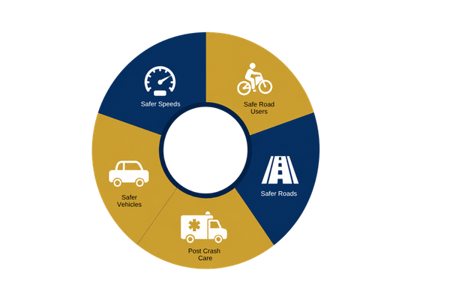
Figure 1. Safe system model
Preventing road trauma depends on all five parts of the safe system working together.
Source: National Road Trauma Centre, adapted from the New Zealand Government’s safe system approach.

About this Resource
This resource provides general public information informed by current evidence and official New Zealand guidance. The National Road Trauma Centre supports current New Zealand legislation, government guidance and evidence-based practice.

References
Ministry of Transport. (2026). New Zealand’s Road Safety Objectives.
NZ Transport Agency Waka Kotahi. (n.d.). Creating a safe road system.
NZ Transport Agency Waka Kotahi. (n.d.). Safe driving habits.
New Zealand Police. (n.d.). Being safe on the road - rules and reasons.
New Zealand Police. (n.d.). Report a road incident or unsafe driver - *555 and Roadwatch.
NZ Transport Agency Waka Kotahi. (n.d.). Standard safety intervention toolkit.
World Health Organization. (2023). Road traffic injuries.

About the National Road Trauma Centre
The Road Traffic Accident Trauma Charitable Trust trading as National Road Trauma Centre works across harm prevention, emergency response, healthcare, rehabilitation and recovery. The National Road Trauma Centre Resource Hub connects trusted information and services without replacing government agencies, emergency services, healthcare providers or support organisations.
If someone is in immediate danger or may be seriously injured, call 111.

