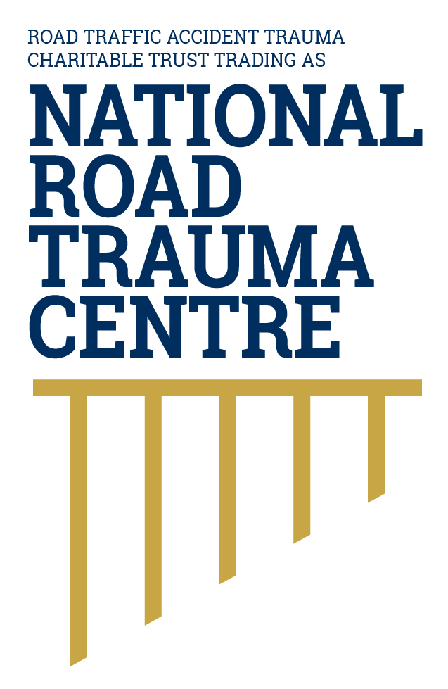
NATIONAL ROAD TRAUMA CENTRE RESOURCE HUB | RESOURCE 01

Understanding the Safe System Approach
Road safety is strongest when the whole transport system is designed to prevent death and serious injury, including when people make mistakes.
The safe system approach starts with a simple reality: people make mistakes, and the human body can tolerate only limited crash forces. It aims to build layers of protection so that one mistake does not result in death or life-changing injury.

Four Principles
- People make mistakes. A safe transport system anticipates foreseeable errors instead of relying on perfect behaviour.
- People are physically vulnerable. Roads, speeds and vehicles must manage the forces transferred to the body in a crash.
- Responsibility is shared. People who design, fund, regulate, build, manage and use the system all contribute to safety.
- Every part must be strengthened. If one protection fails, other protections should still reduce the risk of death or serious injury.

The Parts of a Safer System
- Safer roads and roadsides reduce conflict and make crashes less severe through features such as clear markings, forgiving roadsides, safe intersections and median or roadside barriers.
- Safer speeds give people more time to respond and reduce the energy transferred in a collision.
- Safer vehicles help avoid crashes and protect occupants and other road users when crashes occur.
- Safe road use includes being alert, restrained, unimpaired, attentive and considerate of everyone using the road. Post-crash response and care also affect survival and recovery.

What This Means for You
- Make safe choices, but do not assume behaviour alone can eliminate serious road trauma.
- Choose the safest vehicle you can reasonably access. Wear a seatbelt and use an approved child restraint correctly. In the safe system, the vehicle and restraints work together to reduce movement and the forces placed on the body in a crash.
- Drive at a speed that is safe for the road, traffic, visibility and weather, even when the posted limit is higher. Safer speeds give people more time to react and reduce the force of a crash.
- Support road and transport decisions that protect people who walk, cycle, ride motorcycles, use mobility devices, drive and travel as passengers.

New Zealand Context
In October 2024, the New Zealand Government introduced New Zealand’s Road Safety Objectives, replacing Road to Zero. The Objectives set out the Government’s road safety priorities, focusing on safer roads, safer drivers, safer vehicles and the approach to speed limits. Responsibility for delivering the Objectives is shared by the Ministry of Transport, NZ Transport Agency Waka Kotahi, New Zealand Police and ACC. The Ministry of Transport monitors road safety outcomes and the delivery of agreed actions. NZ Transport Agency Waka Kotahi delivers many road, vehicle, education and safety programmes, while New Zealand Police is responsible for enforcing road laws. The National Road Trauma Centre continues to use safe system principles as an internationally recognised, evidence-based approach to understanding and reducing fatal and serious road trauma.

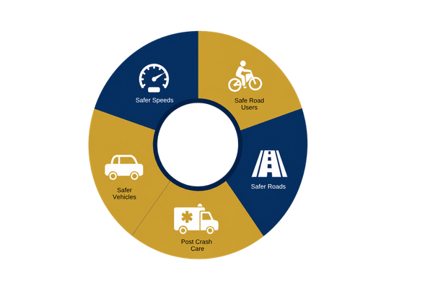
Figure 1. Safe system model
The five parts of the safe system work together to prevent crashes and reduce the severity of injuries when crashes occur.
Source: National Road Trauma Centre, adapted from the New Zealand Government’s safe system approach.

About This Resource
This resource provides general public information informed by current evidence and official New Zealand guidance. The National Road Trauma Centre supports current New Zealand legislation, government guidance and evidence-based practice.

References
Ministry of Transport. (2026). New Zealand’s Road Safety Objectives.
NZ Transport Agency Waka Kotahi. (n.d.). Creating a safe road system.
Ministry of Transport. (2026). Road Safety Objectives Report Q2 2026.
World Health Organization. (2021). Global Plan for the Decade of Action for Road Safety 2021 to 2030.
New Zealand Police. (n.d.). Driving and road safety.

About the National Road Trauma Centre
The Road Traffic Accident Trauma Charitable Trust trading as National Road Trauma Centre works across harm prevention, emergency response, healthcare, rehabilitation and recovery. The National Road Trauma Centre Resource Hub connects trusted information and services without replacing government agencies, emergency services, healthcare providers or support organisations.
If someone is in immediate danger or may be seriously injured, call 111.

