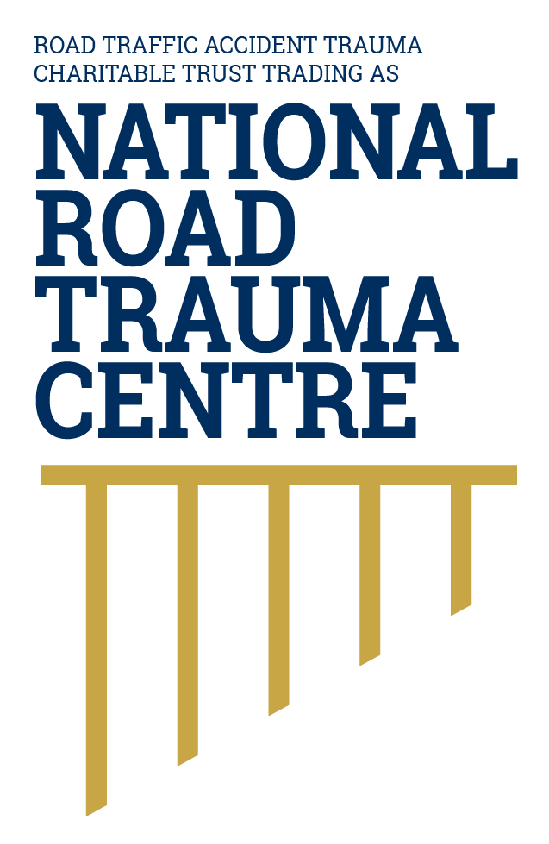



SPONSORSHIP PROPOSAL
CANTERBURY ROAD TRAUMA AWARDS

FOREWORD

The National Road Trauma Centre purpose is to support the wellbeing of New Zealanders impacted directly by road traffic crashes. The purpose of this Strategic Plan is to recognise the requirement for a national strategy to ensure the causation of road trauma and their direct impacts receive the notable consideration in New Zealand it deserves. This Strategic Plan will be the guiding principle to assist the Road Traffic Accident Trauma Charitable Trust trading as the National Road Trauma Centre (“Trust”) to perform strongly to lead change, enhance sector productivity, innovation, leverage new opportunities and connect with national and global strategic objectives.

Energised by our legacy we will continue to work collaboratively with stakeholders and business partners to tackle the challenging issues and complexity the sector faces to improve a culture of health that provides everyone in New Zealand a fair and equitable access to healthcare and support services.

Through strong governance and leadership the Canterbury Road Trauma Awards will help support:

- investment decisions and provision of services that enhance economic growth.
- leverage a government-wide perspective to provide trusted, impartial and influential solutions for better economic outcomes.
- generate long term value-based care, education and training to ensure deliverable services support industry professionals and people in metropolitan, rural and regional communities directly impacted by road trauma.

OUR MISSION

“Our mission is to deliver a centric patient care model that reduces the socio economic impact of road crashes in New Zealand. We will achieve this by working with the community and stakeholders to support a road system free of deaths, serious injuries and harm.”

OUR VALUES

Our commitment to the community and to one another is made evident through the following seven core values, which are central to who we are:

 | PEOPLE  We care for all people and continue to strive to be recognised for our compassion, experience, knowledge and our commitment to excellence to serve our community.
 | PATIENT CARE  We aim to provide high quality patient-focused health care that is readily accessible, cost effective and meets the needs of the communities we serve.
 | INTEGRITY  We pride ourselves on being trusted in our community by always acting in good faith. We adhere to high moral principles and professional standards with a commitment to honesty, confidentiality, trust, respect and transparency.
 | COLLABORATION  We leverage our strengths and capabilities of being ‘all inclusive’ and working together with stakeholders and the community to achieve common objectives that serve delivering sustainable, long term solutions.
 | LEADERSHIP  We lead by example, to always act with integrity by providing leadership to minimise health disparities and support industry professionals.
 | INFLUENCE  We leverage our founding principles by influencing superior quality integrated health care for our community and expanding access for underserved populations within the community.
 | EDUCATION  We pride ourselves on providing high quality educational programmes that add value to our community. We will continue to foster and grow our academic and educational relationships and provide continued community education and resources.

INTRODUCTION

HISTORY

- The Road Traffic Accident Trauma Charitable Trust (‘Trust’) was founded in 2010 and was established to provide clinical support and training to industry professionals deeply impacted by the devastating consequences of road crashes. Motor vehicle crash injuries have the highest rate of major trauma in New Zealand with crashes being one of the leading causes of post traumatic stress disorder in the general population. This was the first Charitable Trust of its kind in New Zealand.

- In 2012 the Trust formed a partnership with the Canterbury Charity Hospital. In 2017, the Hospital donated an office space to the Trust in their newly built Warner Mauger House at 351 Harewood Road, Christchurch.

- In 2016 the Trust organised New Zealand’s first Road Accident Remembrance Day. This is a large public event is to remember those that had passed away in the roads in the Canterbury Region, acknowledge the survivors, thank those involved in the post accident care and recovery, relay important road safety messages and the presentation of the Canterbury Road Trauma Awards. Each year the initiative is well received from those directly impacted by road trauma in our community attendees travelled from Australia and across New Zealand for the event.

AWARD HISTORY

NATIONAL ROAD TRAUMA CENTRE


- The Trust would like to develop a National Road Trauma Centre that will be a New Zealand first innovation hub, with many disciplines catered for under one roof. The Centre will strengthen its value to the community by delivering services that reduces road risks through the integration of ‘sustainable safety’ and healthcare in the view that human life and health is paramount. The Centre would provide a meaningful impact to reduce the socio and economic cost of road trauma in our community. It will meet industry needs and service requirements whilst integrating government strategies, programmes and projects aligned within the sector.

- It is envisaged the Centre will be one of the best practice examples of specialist post trauma care and will take a broader perspective that includes centric needs of patients, including psychological services, clinical nurse co-ordinators, occupational therapists and clinicians. Blending the centric patient care model framework will set a standard unheard of in New Zealand and will be fully integrated with the public health system.

- The Centre will be utilised by researchers, primary health care providers, educational professionals and general office of the Trust. It is envisaged the visitors to the Centre will include those utilising the services of the primary health care providers including emergency services, emergency medicine, health care, transport, roading, infrastructure and educational professionals attending conferences, meetings or training.

STRATEGIC OBJECTIVES

Our strategic objectives are targeted to address the wider socio-economic consequences for those impacted directly and indirectly by road crashes. We aim to provide a collaborative approach to provide the best outcome for local and central government, stakeholders, community and mutual organisations.

STRATEGIC OBJECTIVE ONE: PSYCHOLOGICAL SERVICES

- Deliver centric patient care by removing barriers to inclusion and accessibility for all patients regardless of government mandates.
- Provide ethnically competent, best practice, clinical care that embraces Māori and Pasifika cultural wellbeing. Promote participation and success of priority groups by aligning our activities to the Government’s expectation to provide support services in the most appropriate way.
- Provide patients more control over how they access care, through increasing the range of treatment providers through specific training and education that enhances specialist care amongst clinical psychologists and therapists.
- Remove barriers to equitable care, which includes socio-economic determinants of health outcomes vary between population groups. Ensure those with the highest needs including those who live in poverty, low income or isolated and rural communities receive treatment.
- Provide innovative, world first evidence-based psychological treatment and specialised clinical resources for those impacted by road trauma in accordance with best clinical practice.

MEASURES OF SUCCESS

- Establish an industry based KPI framework for the prevention and treatment of road traffic related trauma which focusses on improving clinical care, providing adequate resourcing for clients and industry professionals and treatment output measures by 2021.
- Ensure psychologists and therapists in New Zealand are adequately equipped to provide road trauma specialist resources and literature that complements the treatment provided and supports elevated rehabilitation and recovery.
- Continue to provide free or significantly reduced fees for psychological services to those directly and indirectly impacted by road crashes. Remove barriers amongst population groups deemed most vulnerable, regardless of government mandates.

STRATEGIC OBJECTIVE TWO: RESEARCH AND DEVELOPMENT

- Establish a dedicated research centre that enhances funding streams for preventative education, improves patient care that fosters innovative solutions for the treatment and prevention of road trauma (psychological and physical injuries).
- Provide a shared resource space for external researchers to enhance efficiency and effectiveness with stakeholders, departments and other organisations who have used their resources.
- Produce evidence-based research which focuses on improving and broadening the scope of post trauma care intervention to enhance access primary health services and clinical treatment for the general population.
- Enhance research to better understand the proportion and the severity of physical and psychological trauma within New Zealand.
- Disseminate research findings at relevant conferences, in publications through peer reviewed scientific journals, and to the wider community through regional public presentations and the media.

MEASURES OF SUCCESS

- Obtain a minimum of two large scale collaborative research grants and discretionary funding to support research by December 2021.
- Annually increase community engagement with research through local and central government, corporate organisations, schools and charitable organisations.
- Build and maintain links with industry professionals within New Zealand and overseas to understand new developments in medical and clinical research by December 2021.
- Undertake epidemiological research to identify individuals and populations at risk by December 2021.
- Research and conference outputs, including public forums and media releases.

STRATEGIC OBJECTIVE THREE: EDUCATION AND TRAINING

- Develop, implement and deliver advanced specialised and economically beneficial workplace and industry-based training utilising local resources and industry professionals, eliminating the need to outsource international experts or training providers.
- Provide existing psychologists and therapists with the advanced specialist clinical care to assist with the treatment, diagnosis and rehabilitation of clients suffering from the post trauma effects of road traffic crashes.
- Provide fully accredited workforce education and professional development opportunities for industry professionals. Address shortages of specialised healthcare providers and expand providers nationally to deliver high quality specialised post trauma care.
- Generate significant inter-professional and continuous learning opportunities for industry professionals through increased workforce development to add insight into marketing, educational programmes and resources and be a fully accredited training provider within New Zealand and Australia.
- Through industry workplace training and research, the Trust will provide defined and exciting career pathways for industry that improves workplace skills and provide exposure to a wide variety of services and projects. This builds new organisational capability and capacity and aids employee retention and stability.

MEASURES OF SUCCESSS

INDUSTRY WORKPLACE TRAINING

- Implement a world first workplace industry training programme treatment and specialised clinical resources for those impacted by road trauma in accordance with best clinical practice by June 2024.
- Reduce the associated training costs for industry professionals by 15% through commercially viable and economically sustainable training model by December 2024.
- Improved workplace safety and patient healthcare errors by 10% through improved training and education programmes amongst industry professionals by December 2022.

PUBLIC EDUCATION

- Produce annual targeted educational resources for the use of the general population for the prevention and treatment of road traffic related injuries.
- Programmes designed to influence the voluntary behaviour of the target audience, and/or raise awareness about a health issue, often using media in various forms.
- Working collaboratively with the public and stakeholders to decrease the mortality rate of road crashes through preventative education to targeted community groups using collateral and an annual communication calendar.
- Develop an updated website framework that has the capacity to meet the key strategic objectives of the Trust by June 2021.
- Ensure all collateral and resource information is readily available online and is tailored to the targeted population groups that meets their needs.
- Build a strong portfolio of health literature available for medical professionals including updated training materials.

COMMUNITY ENGAGEMENT

- Build and maintain strong links with the international community, specifically medicine, psychology and road safety, to link developments in clinical and medical research within New Zealand.
- Improve industry representation by establishing a membership-based network for primary health care providers, health care and emergency service industry professionals that enhances collaboration, connectiveness and co-ordination by December 2021.
- Enhance reward and recognition to industry professionals and the wider general public through the nationalisation of the Canterbury Road Trauma Awards in 2021.
- Continue to implement and deliver the brand strategy that focuses on enhanced brand awareness and recognition, amongst the general population and industry professionals resulting in the National Road Trauma Centre being an easily identifiable prominent service provider by June 2021.

STRATEGIC OBJECTIVE FOUR: CENTRALISED POST TRAUMA CLINICAL CARE

- Establish multidisciplinary teams to integrate primary health care services for those impacted by psychological trauma or injuries following road crashes to accelerate patient independence.
- Enhance sector collaboration by integrating national communication, knowledge sharing, referral and discharge, supported by robust monitoring and evaluation systems to provide more effective patient care.
- Remove the disparity between pre-hospital services available in metropolitan, rural or remote areas. Provide improved support and access to expert advice and support particularly in rural and remote areas and alleviate the financial and or travel burden often associated with people in these communities.

MEASURES OF SUCCESS

- Work with health care and emergency service and relevant stakeholders to establish a five-year post trauma care injury prevention strategy by July 2021.
- Establish of a cross-functional clinical team whose core focus is to enhance centralised post trauma care that reduces hospital admissions and decreases outpatient care by December 2022.
- Establish an electronic national healthcare framework that focuses on improving health and wellbeing amongst those impacted by road crashes through an efficient patient referral system by December 2022.
- Reduce per capita cost of healthcare by 15% for those directly and indirectly involved in road crashes through an increased effort on prevention, early intervention, rehabilitation and the wellbeing of people by December 2023.

STRATEGIC OBJECTIVE FIVE: INJURY PREVENTION/ROAD SAFETY

- Develop a fully integrated road safety model that fosters and encourages industry collaboration, combining ethics, responsibility and sustainability to maximise key government targets and objectives.
- Continue to work together with community network partners to deliver services and outreach along the entire continuum of the Government’s strategy to minimise harm and serious injuries, with a particular focus on key priority areas.
- Enhance medical and road safety collaboration through the range of services provided by the Centre including education and professional development.
- Continue raising public awareness and commitment to road safety and recognition to industry awards professionals.
- Incorporate road safety and trauma prevention reporting at every business level to improve research, changes in policy, clinical and best workplace practice.
- Remain well-informed of key government decisions that effect policy or legislation and respond quickly to emerging needs.
- Host external conferences and training courses for emergency services, medical, health care, transport, roading and infrastructure sectors to provide the sector with a sense of connectedness and collaboration to take a more all-inclusive approach to the prevention of road trauma and serious injury and deaths.
- Leverage technology and innovation through public education that includes promotion of the ‘Safe System’ model, enhances key government legislation and enforcement messages including ‘a safe road system increasingly free of death and serious injury’.
- The Trust will target ongoing reductions in socio and economic relative debt burden of road traffic related crashes, as measured by the Ministry of Transport debt-to-revenue ratio.

MEASURES OF SUCCESSS

- Reduce road traffic related deaths and serious injuries through visible public education by targeted road safety awareness campaigns in alignment with key government priority areas.
- Providing supported accelerated progress in the Government’s ‘Vison Zero’ through a reduction in fatalities and serious injuries through targeted preventative education.
- Work collaboratively with key stakeholders to develop and operate a road safety training programme specifically designed for the explorative learning that enhances general road safety concepts and reduces harm of serious injuries and fatalities.

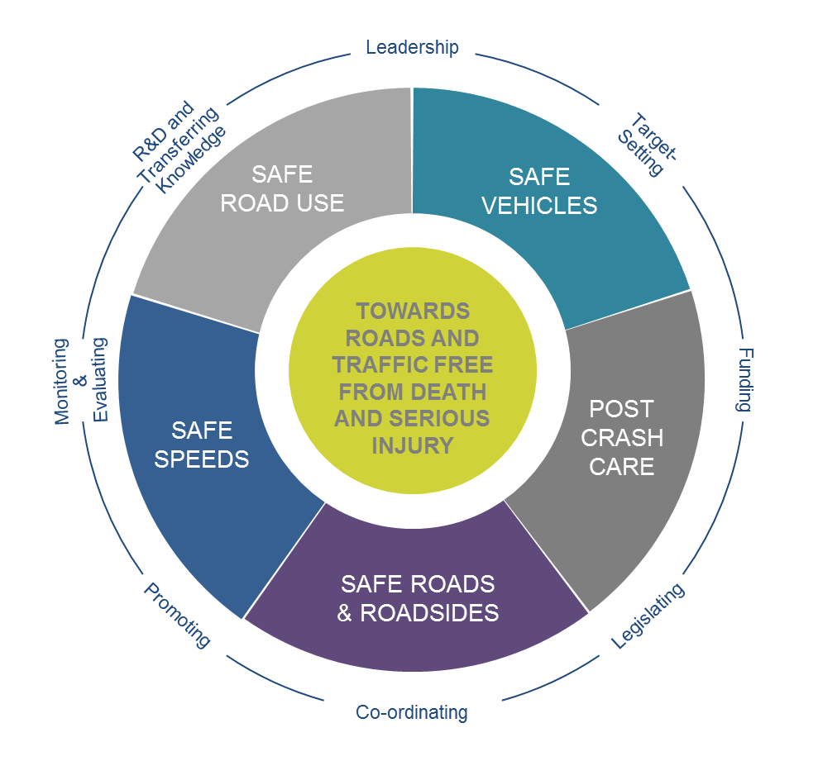
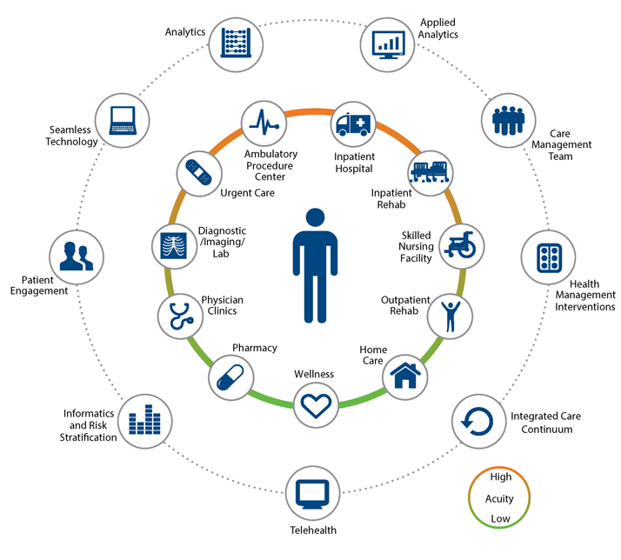
NATIONAL ROAD TRAUMA CENTRE OPERATIONAL MODEL
Shared Purpose
Strategy
Safe System
Centric Patient Care
Centric Patient Care
Organisational Effectiveness
Research
Governance

NATIONAL ROAD TRAUMA CENTRE OPTIONS

The Centre will be developed in stages, according to the Strategic Goal Roadmap. The final objective to have a central place of belonging for those directly and indirectly impacted by road crashes.

Centre options include:

  - Commercial land and building lease

  - University partnership for national road trauma research institute

  - Land purchase and purpose built facility

  - Land lease and purpose built facility.

STRATEGIC GOAL ROADMAP

ONE YEAR : July 2020 - 2021

- Rebrand the Trust to the National Road Trauma Centre and implement Communications Strategy.
- Governance Board to be fully appointed by July 2020.
- Sector consultation and communication commencement.
- Establish National Road Trauma Awards Steering Committee in preparation for the nationalisation of the Canterbury Road Trauma Awards.
- National Road Trauma Centre feasibility study and stakeholder and sector engagement completed.
- Community engagement and consultation Phase I completed.
- Establish two to three new major sponsorship partnerships including major funders.
- Study of rural communities commencement in partnership with Federated Farmers, University and Rural PHO.
- General Manager, Clinical Care Co-Ordinator, Research Director and Marketing Manager to be fully funded and in place.
- Website development Phase I completed. Membership framework completed.
- Nationalisation of the Canterbury Road Trauma Awards.

TWO YEARS - 2022

- Commencement of epidemiological research.
- Obtain accredited workforce education with relevant governing training for industry professionals.
- Clinical Care Co-Ordinator (second role) to be fully funded and in place.
- Investigate Central Government partnership funding for national annual Road Accident Remembrance Day.
- Website development phase II completed to incorporate a member based and non-member based industry programme.
- Source a suitable training venue which provides capability for the Trust to deliver its training services.
- Explore further funding avenues opportunities.
- Present Indicative Business Case to Crown, (dependant on how long research will take).
- Feasibility study location completed.

FUTURE OPPORUTNITIES

- Further development of the Centre.
- Industry workplace training commencement.
- Website development phase III completed.
- Occupational therapists appointed.
- Clinical Psychologist appointed.
- Training Providers positions in place.
- Physical layout completed and expansion of services started.
- Review model to ensure fit for purpose.
- Final expansion phase completed and permanent residence of the National Road Trauma Centre in place.
- All National Road Trauma Centre industry professionals in place and fully funded.

CONTACT:

Sarah Dean
Founder
Patricia Mauger House
Canterbury Charity Hospital
351 Harewood Road
Christchurch
roadtraffictrauma@xtra.co.nz
027 324 0918



Information and data embodied in this document are supplied on the understanding that they will be held confidentially and not disclosed to third
parties without the prior written consent of the Road Traffic Accident Trauma Charitable Trust trading as National Road Trauma Centre.
© Copyright Road Traffic Accident Trauma Charitable Trust trading as National Road Trauma Centre

